**FOTOS DE LOS INTEGRANTES**

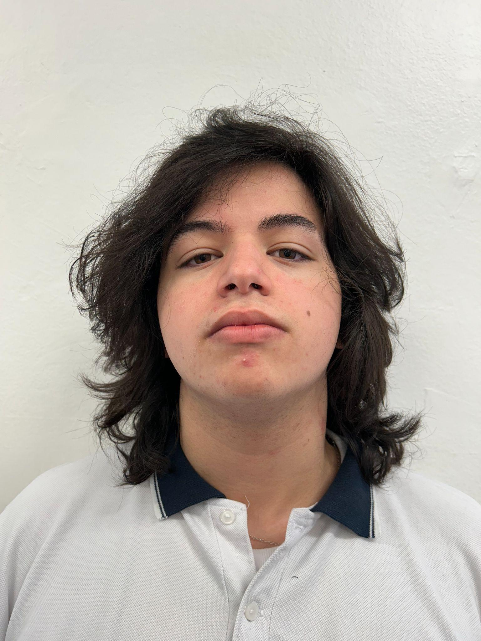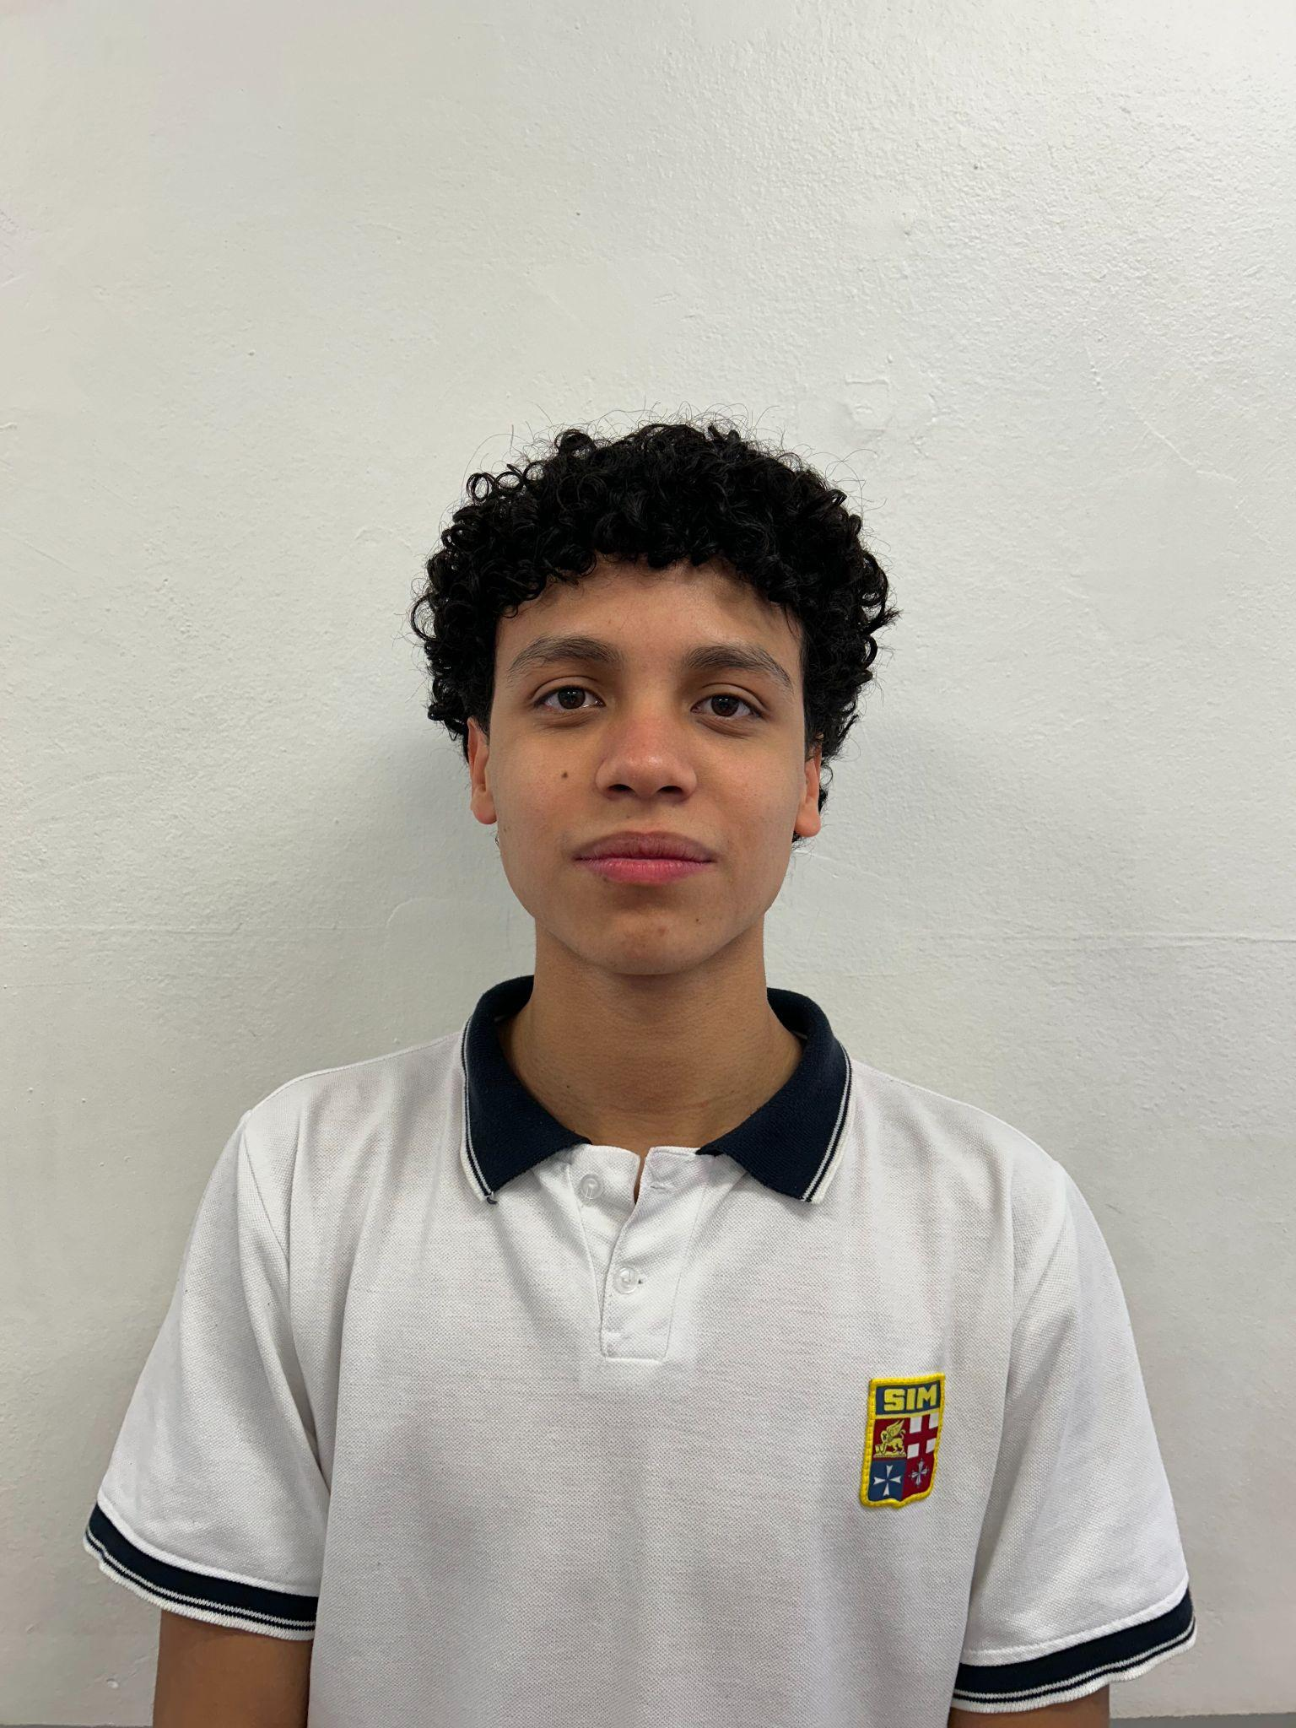

____________________ ____________________

Coordinador Sub-Coordinador

Benavides, Moisés Easton, Mateo

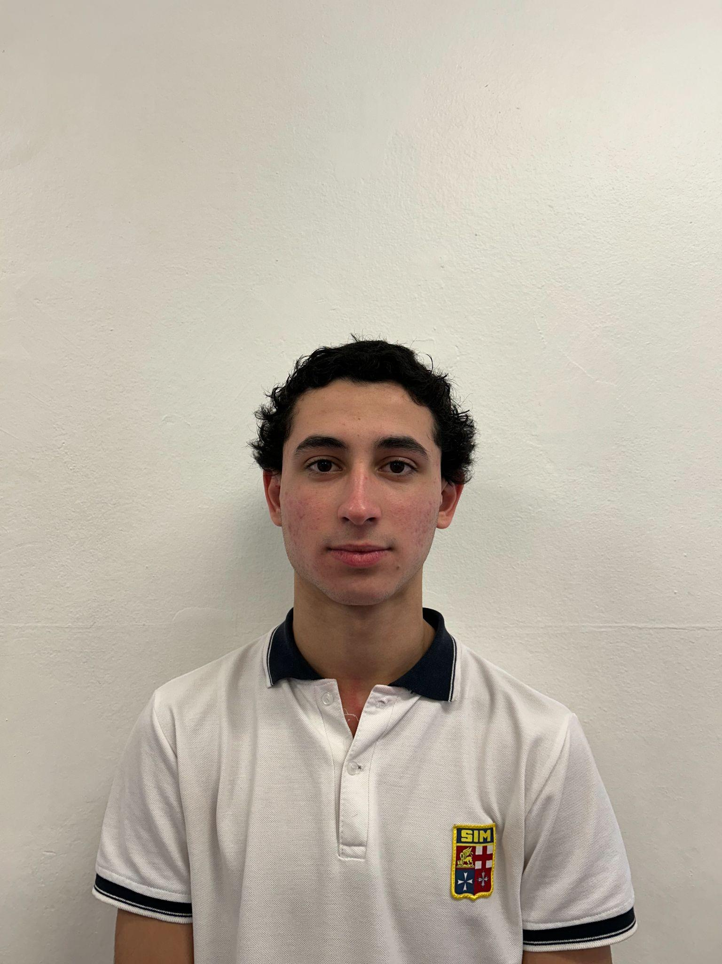

____________________

Integrante 1

Carsillo, Gianni

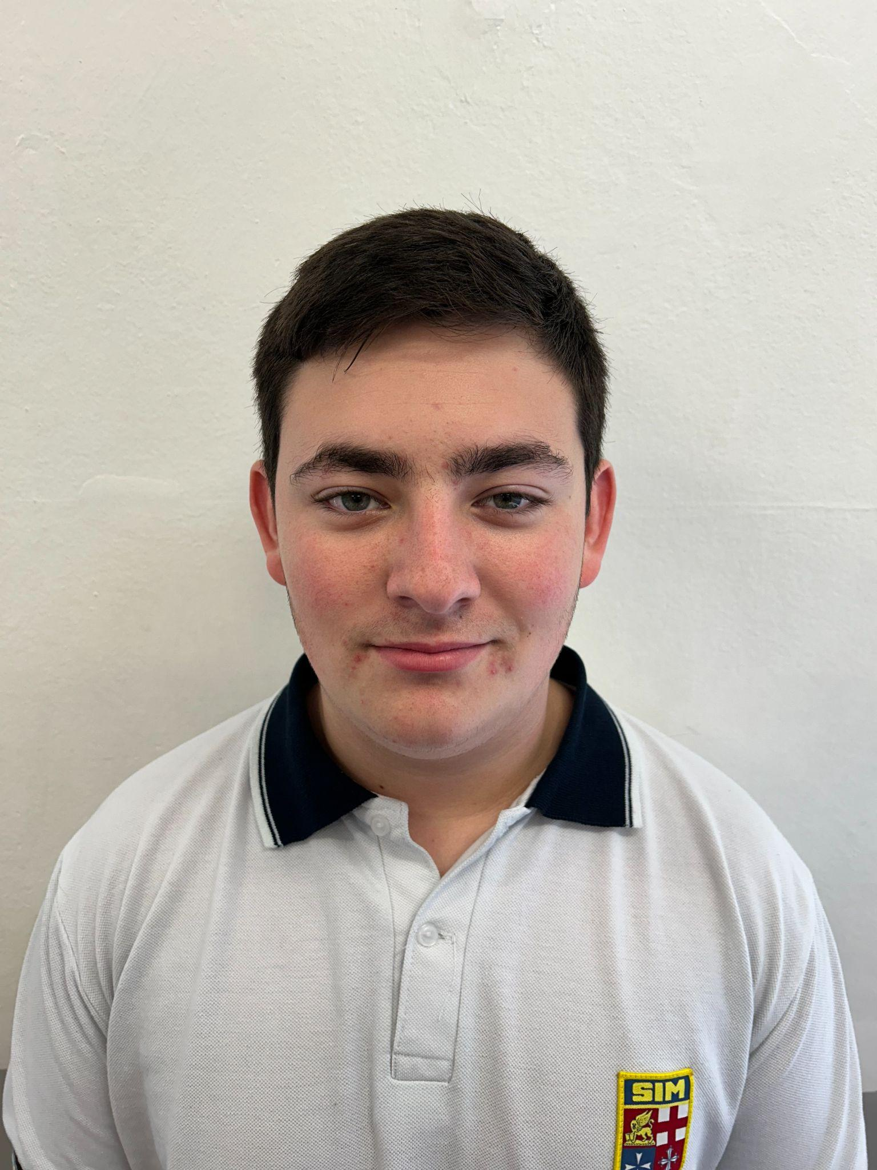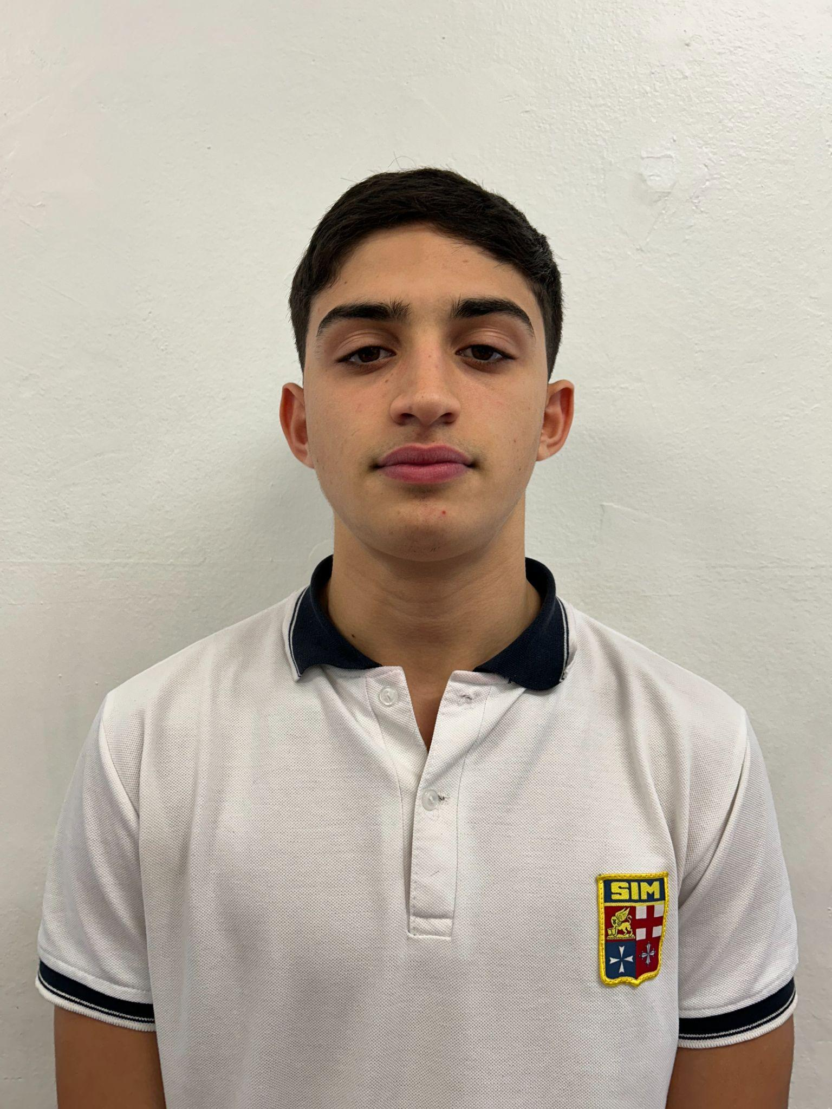

____________________ ____________________

Integrante 2 Integrante 3

Charlo, Lucas Miguelez, Mateo